**Table 1**

**Add-on Basic Statistics**

|  |  |  |  |  |
| --- | --- | --- | --- | --- |
|  | **Mean** | **SD** | **Min** | **Max** |
| Downloads (K) | 7.641 | 18.502 | 11.79 | 283.44 |
| Daily Users (M) | 0.883 | 1.955 | 1.00E-06 | 16.97 |
| Rating Valence Mean | 4.275 | 0.499 | 1 | 5 |
| Rating Variance | 1.46 | 0.76 | 0.48 | 4.2 |
| New Version of Product | 0.015 | 0.123 | 0 | 1 |
| Number of Reviews | 382.64 | 584.93 | 2 | 3686 |
| Size of Developer Team | 1.32 | 0.72 | 1 | 4 |
| Length of time series | 1321.9 | 456.6 | 260 | 1686 |

**Table 2**

**Add-on Categories Basic Statistics**

|  |  |
| --- | --- |
| Appearance | 9 (17%) |
| Bookmarks | 3 (6%) |
| Download Management | 3 (6%) |
| Photo and Multimedia | 9 (17%) |
| Game and Entertainment | 3 (6%) |
| Privacy and Security | 6 (12%) |
| Language Support | 7 (13%) |
| Alerts Updates | 6 (12%) |
| Web Development | 13 (25%) |

**Table 3**

**Platform Basic Statistics**

|  |  |  |  |  |
| --- | --- | --- | --- | --- |
|  | **Mean** | **SD** | **Min** | **Max** |
| Mozilla Firefox daily Users (M) | 229 | 16 | 185 | 262 |
| Total number of add-ons create per day | 128 | 192 | 4 | 2,418 |
| Google Chrome daily Users (M) | 189 | 119 | 20 | 432 |
| Microsoft Internet Explorer (IE) daily Users (M) | 354 | 47 | 240 | 437 |
| Total number of weekly AMO Editor’s contribution | 1,444 | 442 | 794 | 2,620 |
| Total length of the AMO nomination queue | 362 | 220 | 80 | 949 |

**Table 4**

**License Description**

|  |  |  |  |  |  |  |
| --- | --- | --- | --- | --- | --- | --- |
| **Item** | **BSD** | **MIT/X11** | **Mozilla** | **GNU** | **Custom** | |
| Provides copyright protection | TRUE | TRUE | TRUE | TRUE | TRUE |
| Can be used in commercial applications | TRUE | TRUE | TRUE | TRUE | FALSE |
| Bug fixes / extensions must be released to the public domain | FALSE | FALSE | TRUE | TRUE | TRUE |
| Provides an explicit patent license | FALSE | FALSE | TRUE | FALSE | FALSE |
| Can be used in proprietary (closed source) applications | TRUE | TRUE | TRUE | FALSE | FALSE |
| Is a viral license | FALSE | FALSE | FALSE | TRUE | FALSE |

**Table 5**

**Descriptive Statistics of Licenses and Incentives**

|  |  |  |
| --- | --- | --- |
| **Item** | **Type** | **Frequency** |
| License | Fully free (MIT/X11,BSD) | 5 |
|  | Restricted (GNU, Custom) | 41 |
|  | Mozilla | 2 |
| Incentive | Contribute | 25 |
|  | Meet Developer | 10 |

**Table 6**

**MODEL COMPARISON**

|  |  |  |  |  |
| --- | --- | --- | --- | --- |
| **Model** | **Description** | **DIC** |  |  |
| 1 | No Churn | 393,181,425 | 196,887,137 | 296,425 |
| 2 | No Version Carry Over | 393,249,002 | 196,921,381 | 296,881 |
| 3 | No AMO effect on platform | 393,258,460 | 196,926,790 | 297,560 |
| 4 | Interaction model | 393,224,624 | 196,921,662 | 309,350 |
| 5 | Unexplained internal market force of add-ons | 393,183,354 | 196,889,620 | 297,942 |
| 6 | Unexplained external market force of add-ons | 393,229,107 | 196,907,050 | 292,496 |
| 7 | Unexplained churn | 393,265,094 | 196,298,559 | 297,309 |
| 8 | No cumulative effect of add-on creation on platform | 393,220,649 | 196,903,764 | 293,439 |
| 9 | Unexplained relevance factor | 393,338,158 | 196,971,387 | 302,309 |
| 10 | Proposed Model | 393,029,826 | 196,694,177 | 179,264 |

**Table 7**

**Performance of the Proposed Model for Four Sample Add-ons and Platform**

|  |  |  |
| --- | --- | --- |
| **Description** | **MAD** | **MSE** |
| Firefox Platform | 1.20e-04 | 2.04e-05 |
| Auto-Pager Add-on | 0.0016 | 4.71e-06 |
| Google Translator for Firefox Add-on | 0.0012 | 3.34e-06 |
| Ad-block Plus Add-on | 0.0049 | 3.97e-05 |
| Stealthy Add-on | 0.0032 | 1.32e-05 |

**Table 7**

**PARAMETER ESTIMATES: PLATFORM**

|  |  |  |  |  |
| --- | --- | --- | --- | --- |
|  | **Estimate** | **Std. Dev.** | **2.5th** | **97.5th** |
| Market size | 1.54E-02 | 1.52E-06 | 1.54E-02 | 1.54E-02 |
| Unobserved Internal Market Force | 1.76E-03 | 1.52E-06 | 1.76E-03 | 1.76E-03 |
| Unobserved Internal Market Force | 1.27E-08 | 9.02E-09 | -2.03E-09 | 2.77E-08 |
| Total Add-ons Created | 3.60E-02 | 1.51E-06 | 3.60E-02 | 3.60E-02 |
| Competition: |  |  |  |  |
| Chrome | -4.91E-05 | 1.51E-06 | -5.17E-05 | -4.73E-05 |
| Internet Explorer | -5.66E-04 | 1.52E-06 | -5.68E-04 | -5.64E-04 |
| AMO: |  |  |  |  |
| Total number of contributions | 3.42E-05 | 1.51E-06 | 3.16E-05 | 3.61E-05 |
| Length of the Queue | 3.52E-05 | 1.51E-06 | 3.26E-05 | 3.70E-05 |
| Variances: |  |  |  |  |
| Observation Equation | 1.44E-02 | 4.30E-03 | 8.52E-03 | 2.30E-02 |
| State Equation | 1.12E-01 | 8.35E-03 | 9.75E-02 | 1.25E-01 |

**Table 8**

**PARAMETER ESTIMATES: ADD-ONS**

|  |  |  |  |  |
| --- | --- | --- | --- | --- |
|  | **Estimate** | **Std. Dev.** | **2.5th** | **97.5th** |
| Relevance factor | 0.0142 | 0.0019 | 0.0104 | 0.0179 |
| Churn factor | 0.0174 | 0.0021 | 0.0132 | 0.0215 |
| External Market Force: |  |  |  |  |
| Unobserved | 0.0087 | 0.0018 | 0.0051 | 0.0123 |
| Add-on New Version | 0.0047 | 0.0011 | 0.0026 | 0.0067 |
| Platform New Version | 0.0059 | 0.0012 | 0.0035 | 0.0083 |
| Internal Market Force: |  |  |  |  |
| Unobserved | 0.0057 | 0.0014 | 0.0030 | 0.0085 |
| Rating Variance | 0.0131 | 0.0018 | 0.0096 | 0.0167 |
| Observational Learning | 0.0054 | 0.0016 | 0.0022 | 0.0086 |
| Rating mean | 0.0043 | 0.0014 | 0.0016 | 0.0070 |
| Variance: |  |  |  |  |
| Observation Equation | 0.0002 | 1.56E-05 | 0.0002 | 0.0002 |
| State Equation | 0.0002 | 1.74E-05 | 0.0002 | 0.0003 |

**Table 9**

**PARAMETER HETEROGENEITY**

|  |  |  |  |  |  |
| --- | --- | --- | --- | --- | --- |
|  |  | **Estimate** | **STD** | **2.5th** | **97.5th** |
| Relevance factor | Intercept | 0.014 | 0.007 | 0.002 | 0.026 |
|  | Ask for money contribution | 0.010 | 0.016 | -0.017 | 0.038 |
|  | Meet the developer option | -0.003 | 0.020 | -0.037 | 0.030 |
|  | Fully Free License | 0.001 | 0.034 | -0.056 | 0.057 |
|  | Restricted Licenses | 0.006 | 0.027 | -0.039 | 0.051 |
|  | Mozilla License | -0.001 | 0.046 | -0.076 | 0.073 |
| Churn factor | Intercept | 0.014 | 0.007 | 0.003 | 0.026 |
|  | Ask for money contribution | 0.010 | 0.016 | -0.017 | 0.037 |
|  | Meet the developer option | -0.003 | 0.021 | -0.037 | 0.032 |
|  | Fully Free License | 0.001 | 0.034 | -0.055 | 0.056 |
|  | Restricted Licenses | 0.007 | 0.026 | -0.037 | 0.051 |
|  | Mozilla License | 0.000 | 0.045 | -0.073 | 0.073 |
| External Market Force |  |  |  |  |  |
| Unobserved | Intercept | 0.014 | 0.007 | 0.002 | 0.025 |
|  | Ask for money contribution | 0.011 | 0.016 | -0.016 | 0.038 |
|  | Meet the developer option | -0.003 | 0.020 | -0.036 | 0.031 |
|  | Fully Free License | 0.001 | 0.034 | -0.055 | 0.056 |
|  | Restricted Licenses | 0.007 | 0.027 | -0.036 | 0.051 |
|  | Mozilla License | -0.001 | 0.045 | -0.075 | 0.072 |
| Add-on New Version | Intercept | 0.009 | 0.007 | -0.003 | 0.021 |
|  | Ask for money contribution | 0.000 | 0.017 | -0.028 | 0.027 |
|  | Meet the developer option | 0.009 | 0.022 | -0.027 | 0.045 |
|  | Fully Free License | -0.019 | 0.036 | -0.077 | 0.039 |
|  | Restricted Licenses | -0.005 | 0.028 | -0.051 | 0.041 |
|  | Mozilla License | -0.013 | 0.047 | -0.091 | 0.063 |
| Platform New Version | Intercept | 0.005 | 0.007 | -0.007 | 0.016 |
|  | Ask for money contribution | -0.001 | 0.017 | -0.030 | 0.028 |
|  | Meet the developer option | 0.014 | 0.023 | -0.023 | 0.051 |
|  | Fully Free License | -0.014 | 0.036 | -0.074 | 0.045 |
|  | Restricted Licenses | -0.004 | 0.028 | -0.050 | 0.043 |
|  | Mozilla License | 0.000 | 0.048 | -0.080 | 0.078 |
| Internal Market Force |  |  |  |  |  |
| Unobserved | Intercept | 0.014 | 0.007 | 0.003 | 0.026 |
|  | Fully Free License | -0.001 | 0.034 | -0.058 | 0.056 |
|  | Restricted Licenses | 0.006 | 0.027 | -0.039 | 0.050 |
|  | Mozilla License | -0.002 | 0.045 | -0.077 | 0.072 |
|  | Ask for money contribution | 0.000 | 0.029 | -0.048 | 0.047 |
|  | Meet the developer option | -0.003 | 0.021 | -0.037 | 0.032 |
|  | Asked contribution amount | 0.002 | 0.004 | -0.004 | 0.007 |
| Rating Variance | Intercept | 0.009 | 0.007 | -0.004 | 0.021 |
|  | Fully Free License | -0.018 | 0.036 | -0.076 | 0.040 |
|  | Restricted Licenses | -0.005 | 0.028 | -0.051 | 0.042 |
|  | Mozilla License | -0.014 | 0.046 | -0.091 | 0.062 |
|  | Ask for money contribution | 0.001 | 0.029 | -0.048 | 0.049 |
|  | Meet the developer option | 0.009 | 0.022 | -0.026 | 0.045 |
|  | Asked contribution amount | 0.000 | 0.004 | -0.006 | 0.006 |
| Observational Learning | Intercept | 0.005 | 0.007 | -0.007 | 0.017 |
|  | Fully Free License | -0.015 | 0.037 | -0.076 | 0.046 |
|  | Restricted Licenses | -0.004 | 0.029 | -0.051 | 0.043 |
|  | Mozilla License | -0.003 | 0.048 | -0.081 | 0.076 |
|  | Ask for money contribution | -0.003 | 0.029 | -0.051 | 0.046 |
|  | Meet the developer option | 0.013 | 0.022 | -0.024 | 0.049 |
|  | Asked contribution amount | 0.000 | 0.004 | -0.006 | 0.006 |
| Rating mean | Intercept | 0.006 | 0.007 | -0.006 | 0.018 |
|  | Fully Free License | -0.010 | 0.036 | -0.069 | 0.049 |
|  | Restricted Licenses | -0.003 | 0.029 | -0.050 | 0.044 |
|  | Mozilla License | 0.021 | 0.048 | -0.058 | 0.100 |
|  | Ask for money contribution | -0.001 | 0.029 | -0.050 | 0.048 |
|  | Meet the developer option | 0.010 | 0.023 | -0.028 | 0.048 |
|  | Asked contribution amount | 0.000 | 0.004 | -0.006 | 0.006 |

**Figure 1**

**Mozilla Community Structure**

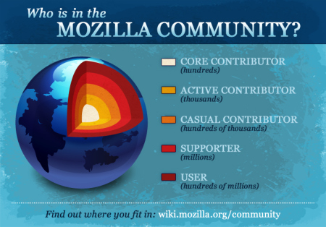

**Figure 2**

**Box and Arrow Representation of the Model**

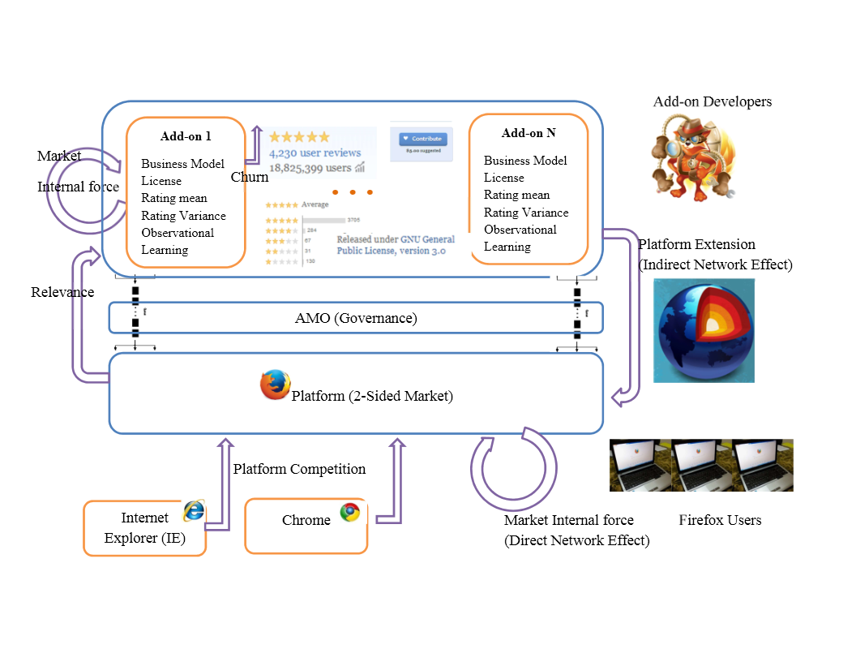

**Figure 3**

**Platform Diffusion Data**

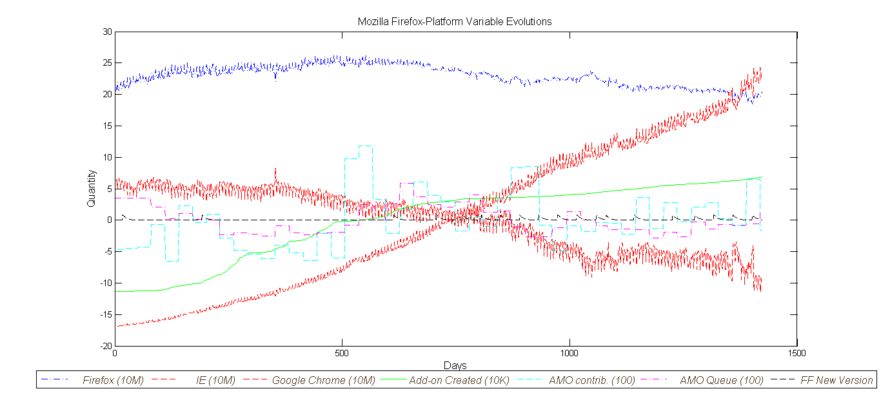

**Figure 4**

**Add-on Daily Downloads**

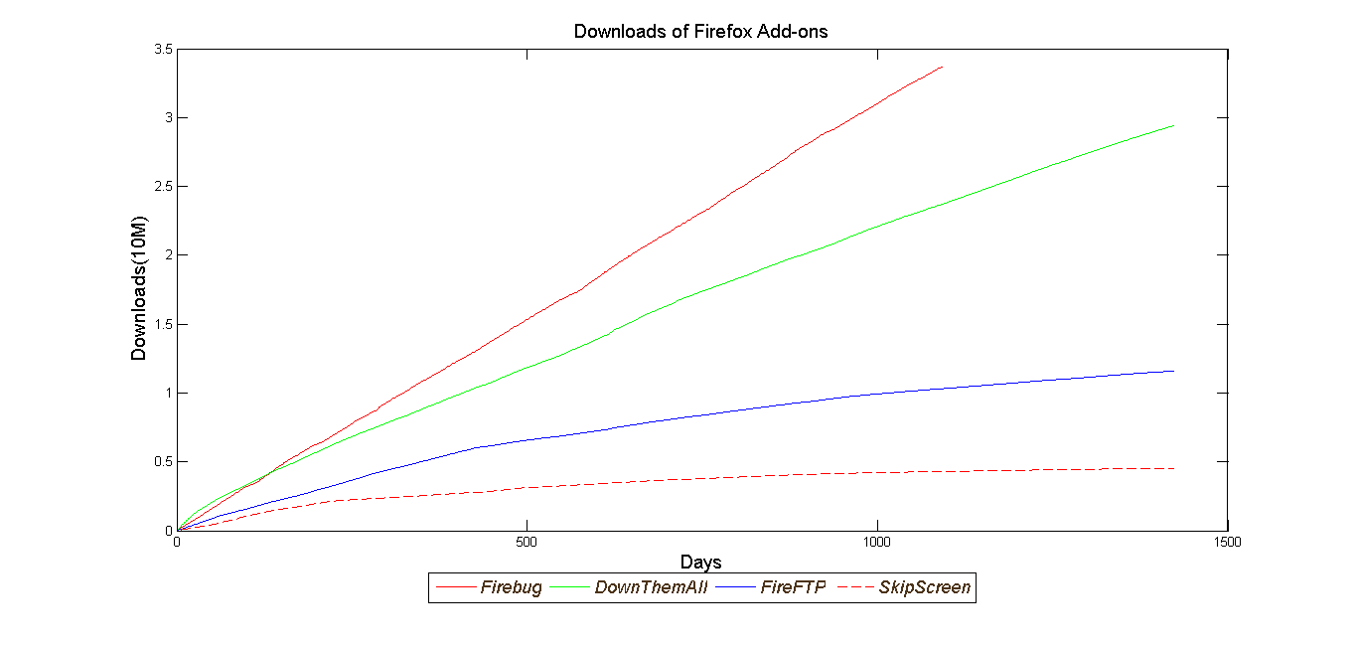

**Figure 4**

**Add-on Daily New Version**

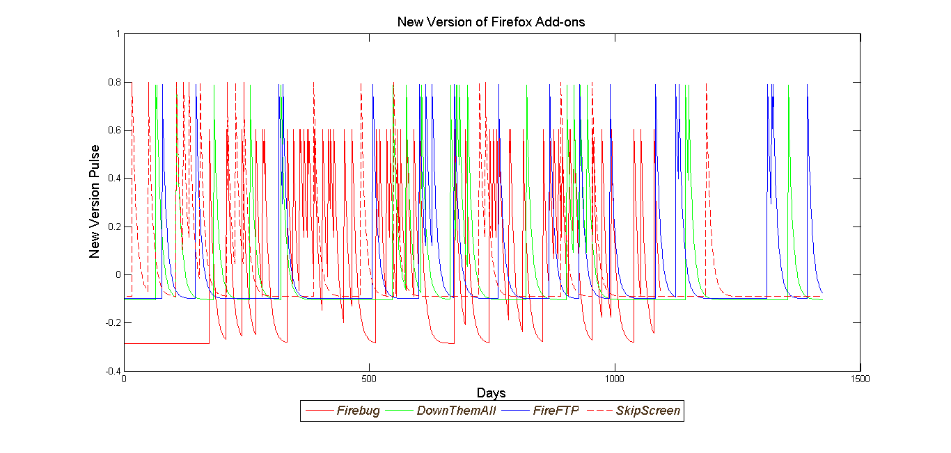

**Figure 4**

**Add-on Daily Variance of Rating**

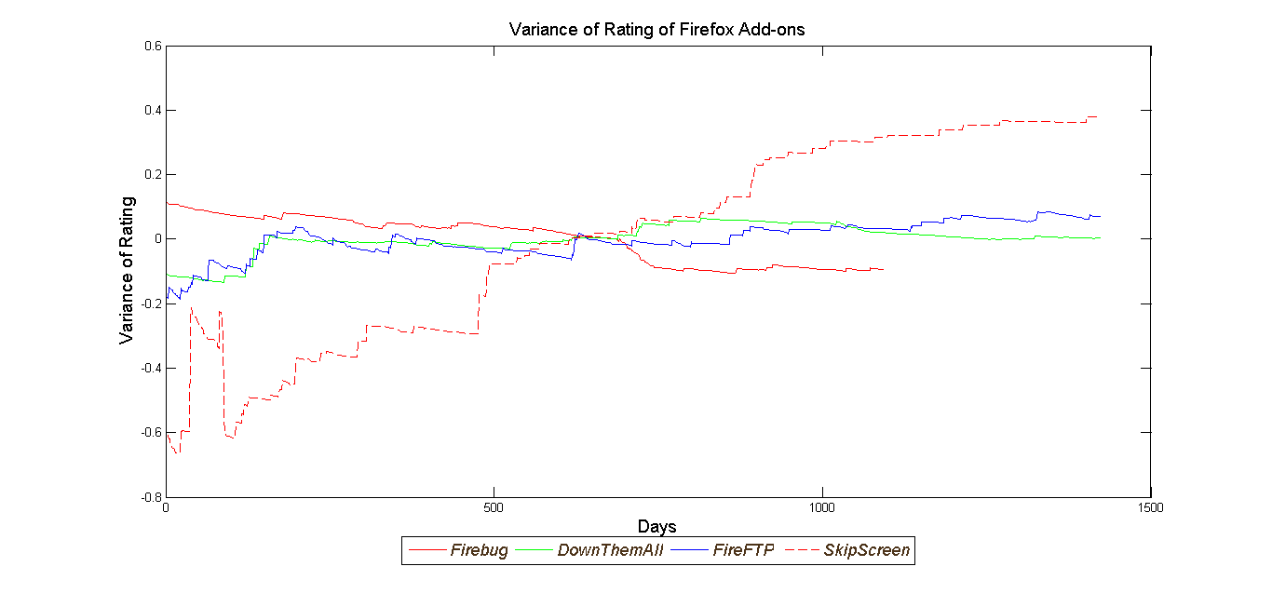

**Figure 4**

**Add-on Daily Users**

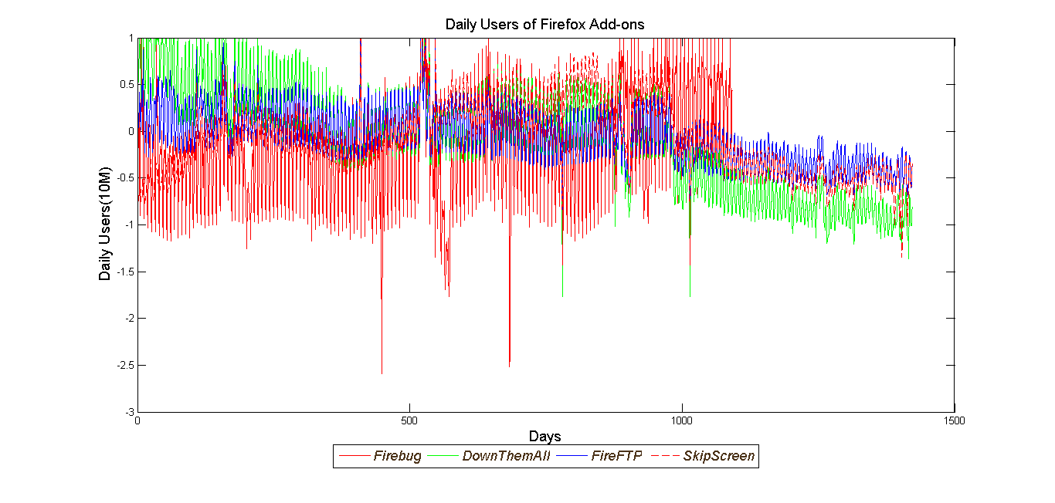

**Figure 4**

**One-Step Ahead Forecast of Four Sample Add-on’s Cumulative Downloads**

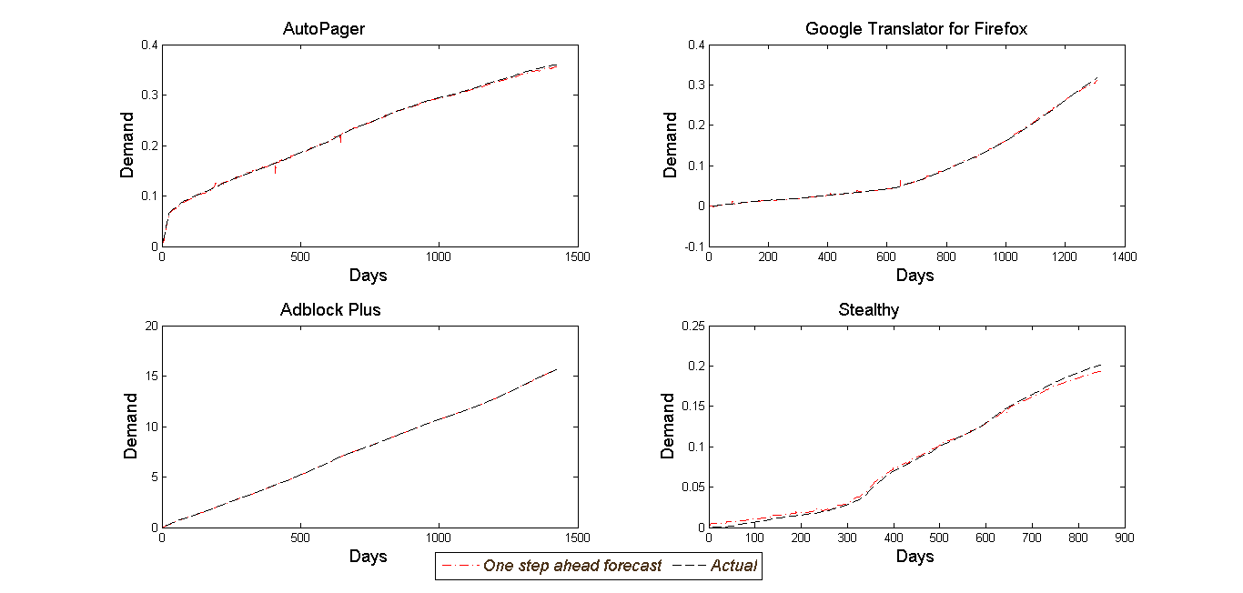

**Figure 5**

**One-Step Ahead Forecast of Firefox Platform Daily Users**

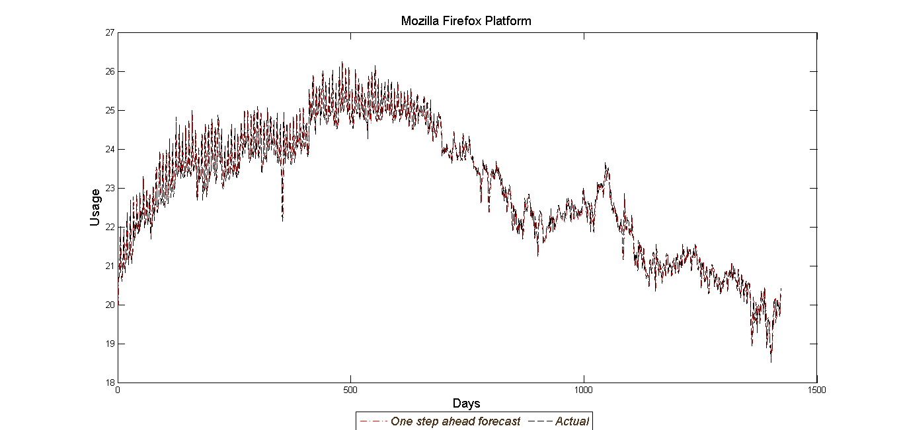

**Figure 6**

**Histogram of Parameter Estimate Across Add-ons**

